**DATA VISUALIZATION PROJECT**

**IS-683**

***Submitted by -:***

*Revant Chandanala(rc296@njit.edu)*

*Puneeth Thimmoji Somasekhara(*[*pt78@njit.edu*](mailto:pt78@njit.edu)*)*



**PROJECT DESCRIPTION**

Data visualization is the study of the visual representation of data, meaning "information that has been abstracted in some schematic form, including attributes or variables for the units of information". The main goal of data visualization is to communicate information clearly and effectively through graphical means.

The project involves representation of data in the form of line graph. Here ,we collect stock prices of Apple company and display them in the form of graph. We show the data for different periods , like past one month ,six months etc. In this project ,we are collecting data into csv (Comma separated values) file . To start the project , first we run the app.js file ,which is the server . The server reads the csv file and stores it into an array and sends it to the client . At the client side, it reads the array and displays it in the form of graph .

**INDIVIDUAL ROLES**

Revant Chandanala :

I designed the front end part and wrote the code for client side . Also , I collected the data set for the stock prices of Apple Company.

Puneeth Thimmoji somashekara :

I designed the back-end and wrote the code for server side. Server reads the csv file and pushes the data to the array. Later this array is sent to client where it is plotted on the graph.

**SCREENSHOTS**

1. Displays stock prices for past one month .

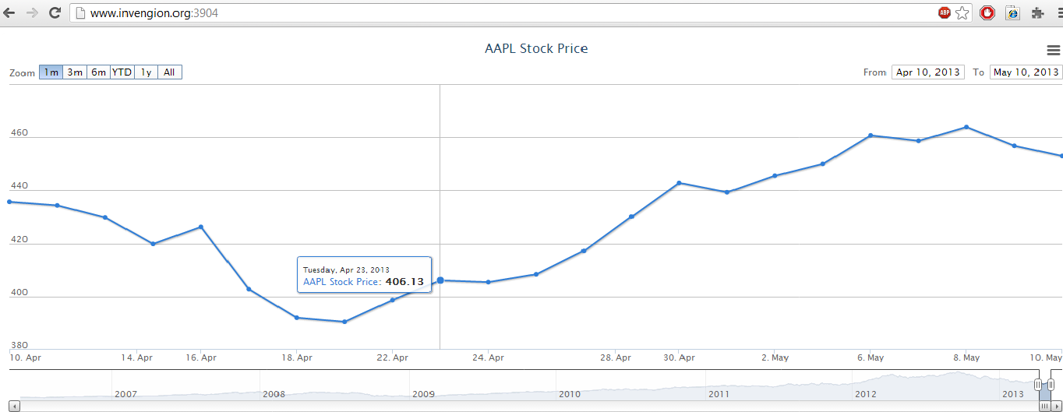

2. Displays stock prices for past three months.

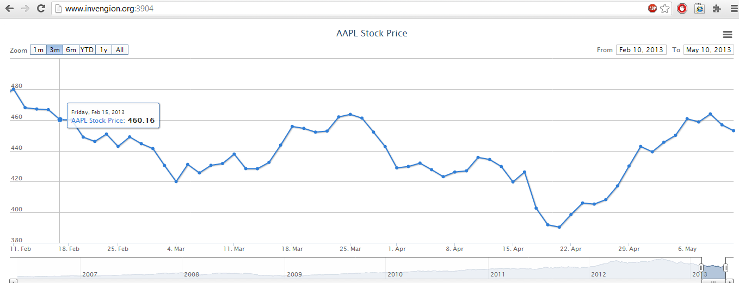

3. Displays stock prices for past six months.

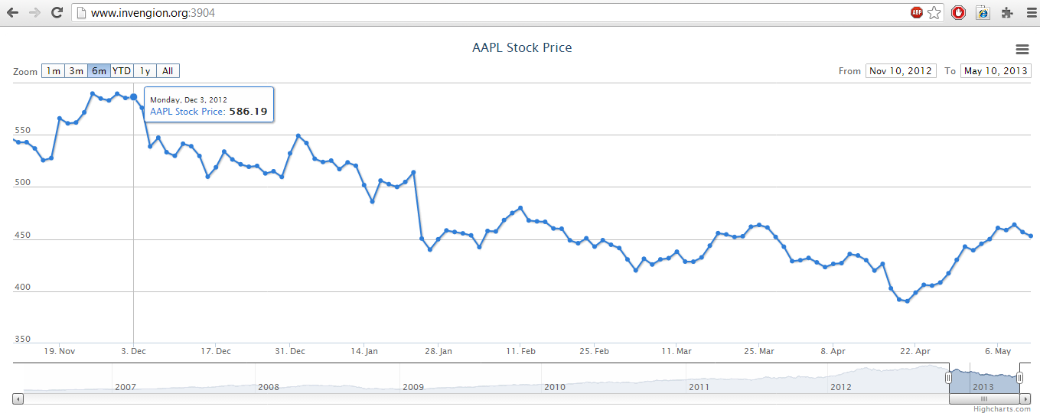

4. Displays stock prices from start of the year upto this date.

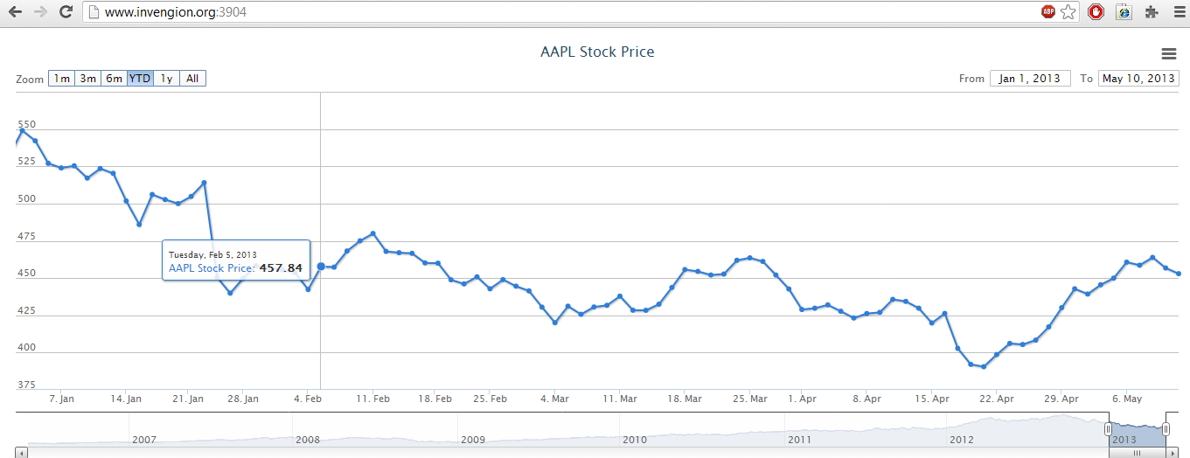

5. Displays stock prices for past one year.

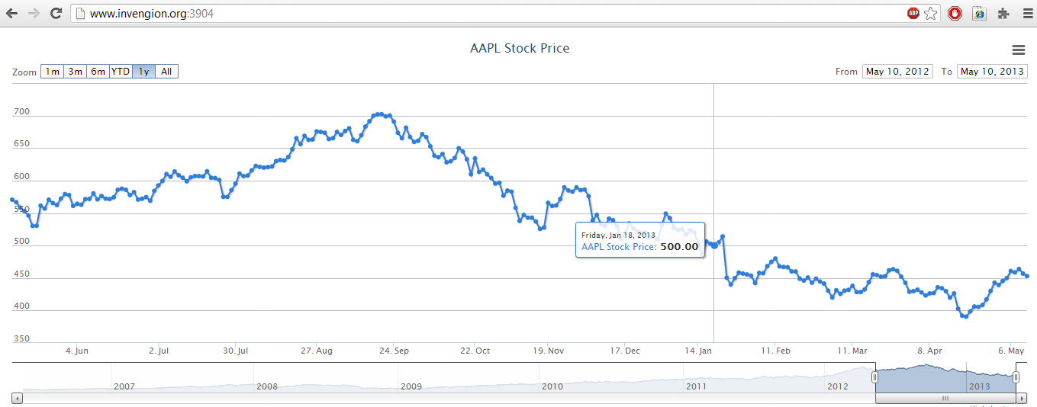

6. Displays stock prices from May 2006.

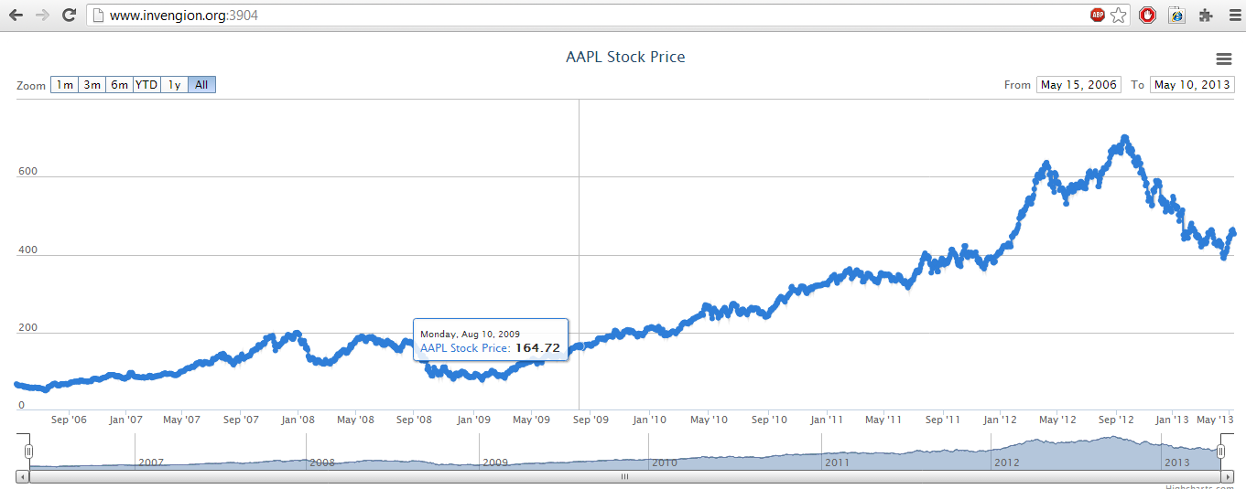

**SOURCE CODE**

1. **Client Side (index.html)**

<!DOCTYPE HTML>

<html>

<head>

<script src="/socket.io/socket.io.js"></script>

<script>

var socket = io.connect('http://www.invengion.org:3904');

socket.on('news', function (data) {

console.log(data);

socket.emit('my other event', { my: 'data' });

});

</script>

<meta http-equiv="Content-Type" content="text/html; charset=utf-8">

<title>Data Visualization Project</title>

<script type="text/javascript" src="http://ajax.googleapis.com/ajax/libs/jquery/1.8.2/jquery.min.js"></script>

<script type="text/javascript">

$(function() {

$.getJSON('http://www.highcharts.com/samples/data/jsonp.php?filename=aapl-c.json&callback=?', function(data) {

// Create the chart

$('#container').highcharts('StockChart', {

rangeSelector : {

selected : 1

},

title : {

text : 'AAPL Stock Price'

},

series : [{

name : 'AAPL Stock Price',

data : data,

marker : {

enabled : true,

radius : 3

},

shadow : true,

tooltip : {

valueDecimals : 2

}

}]

});

});

});

</script>

</head>

<body>

<script src="http://code.highcharts.com/stock/highstock.js"></script>

<script src="http://code.highcharts.com/stock/modules/exporting.js"></script>

<div id="container" style="height: 500px; min-width: 500px"></div>

</body>

</html>

2. **Server Side (app.js)**

var app = require('http').createServer(handler)

, io = require('socket.io').listen(app)

, fs = require('fs');

var csv = require('csv');

app.listen(3904);

var a=[];

function handler (req, res) {

fs.readFile(__dirname + '/index.html',

function (err, data) {

if (err) {

res.writeHead(500);

return res.end('Error loading index.html');

}

res.writeHead(200);

res.end(data);

});

}

io.sockets.on('connection', function (socket) {

csv()

.from.stream(fs.createReadStream(__dirname+ '/table.csv'), {

columns: ['date', 'open', 'high', 'Low',

'close']

})

.on('record', function(data) {

for ( var type in data){

a.push([[data]]);

}

})

.on('end', function() {

console.log("I'm here!");socket.emit( 'send_array', {chats:a});

console.log('done');

}) .on('error', function(error) {

console.log(error.message); }) ;

});